Pay to Park in Combe Martin Parish Council Car Parks with RingGo
If you’re paying to park in Combe Martin Parish Council car parks, you can now use the RingGo parking app. Paying to park by phone is quick and easy and means you don’t have to hunt for change or touch a shared machine.

For a list of places where you can pay to park with RingGo in Combe Martin, please see RingGo | Locations - Search for the parking location that suits you

Once you’ve downloaded the free RingGo app and registered, you can also pay to park in tens of thousands of RingGo locations nationwide.

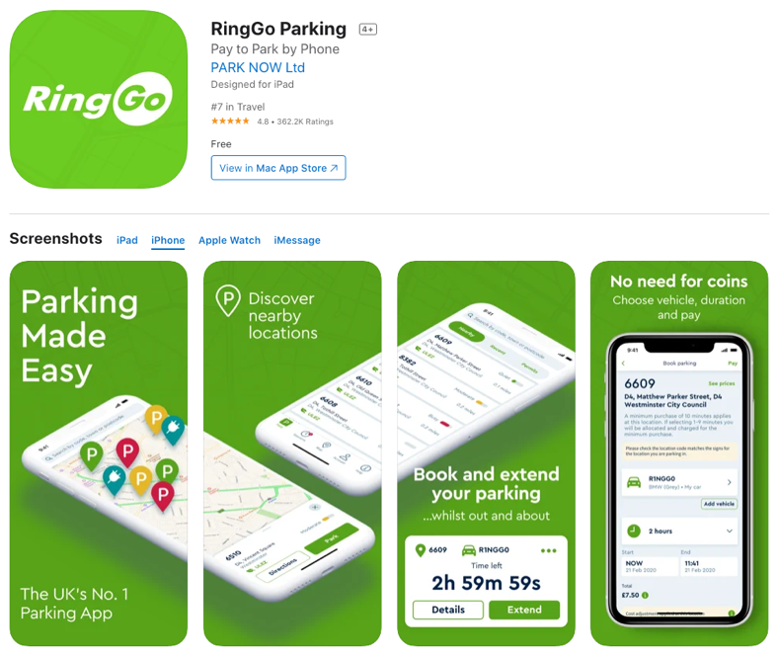
How does RingGo work?
To download the RingGo app, go to your phone’s App Store or Google Play Store and search for RingGo. Once you’ve downloaded the app, set up your account by registering a few details and when you want to park, you can pay in seconds.

Once you’re parked in an area where RingGo is offered, you need to confirm the vehicle you’re using and let the service know exactly where you are parked. You do this by entering the four or five digit location number, advertised on local signs.

For example, if a RingGo sign displays “1234”, this would be the location code you would enter on your mobile. You then just have to say how long you’re staying and confirm your payment details.

Another benefit of phone parking is that if your parking is running out, you can extend your time wherever you are by using the RingGo app. Just select your current session from the sessions tab and the app will ask you how long you want to extend for. Choose a time, confirm, and you’re good to go.

With RingGo, you’ll never need a ticket from the machine again. Parking enforcement officers know you’re parked with the service by checking the vehicle registration on their devices, so there’s no need to trek to and from, or queue at, the parking machine either.

What are the benefits of using RingGo to park?
- TouchFree parking without having to visit or use a machine.
- No more coins – you’ll never have to worry about carrying change to pay for parking again. Just download the RingGo app.
- Extend your parking. If you want to stay a bit longer or you’re running late, just click the extend button in the RingGo app, wherever you are. No need to dash back to your car.
- No more tickets. Our handy reminders alert you when your parking is running out and you can top up too, lowering stress about getting a possible Penalty Charge Notice.
- Finally, there’s no need to hang about in the dark or bad weather. Why get cold or wet when you can pay for parking quickly and securely from the comfort of your car?

Tell me more
There is a small 10p convenience fee charged per RingGo session or extension.

The optional confirmation and alert texts cost 10p per message, but you can opt-out of these at any time.

You can get VAT receipts for all your parking sessions either through the free RingGo parking app, or on the RingGo website.

If you park for business check out the RingGo Corporate solution for business parking at RingGo.co.uk/corporate.

If you’re not a smartphone user, you can still use RingGo to pay for your parking in Combe Martin by calling 01271 470050.

You can also register and book parking with RingGo online.

If you need any more information, please visit RingGo.co.uk.

