Minutes of the Combe Martin Parish Council Meeting,
held on 12th January 2026 at 7pm at Combe Martin Community Centre.

Present: Cllrs. Seldon (Chairman), Corner, Lethaby, Masters, Molloy, and Worth.
Also in attendance: DCC Cllr. Davis, Andrew Wyer (Clerk) and 7 members of the public.

179/25 Apologies – Apologies were received and accepted from Cllrs. Cass, Galloway, Smallridge, Richards, Watkins, and Optix.
180/25 Declarations of Interest – Cllr Lethaby declared that as a District Councillor, the views he gives (and how he votes) at this meeting will not necessarily be the same as he does at a District Council meeting and in Agenda Item 15 (Min 193/25).
181/25 Public Participation questions (with any answers in brackets):
What has happened to the Community Land Trust? (We are not sure, but it may have disbanded?)
With regards to flood resilience, is anything being done to stop water being held back by the bridge by the church? (The EA are doing nothing about that bridge/culvert specifically)
With regards to the river level sensors and the mobile phone technology they use to report their data, has anyone considered the harm being done to the fish by this radiation?
Please can the Council plant more fruit trees? (The Council has planted some at the bottom of Barton Gate Lane and wants to plant an orchard at Wood Lane but this can’t be done until we have planning permission for the Men in Sheds/Council store building.)
One of the cherry? trees at the top of Hollands Park is looking quite sick? (We would replace it with a fruit tree if required.)
182/25 Minutes – The Minutes for the Council meeting held on Monday 8th December 2025 were approved and signed.
183/25 Clerks Report – The report was distributed at the meeting, and the Council noted it. The Council are willing to help the museum by replacing the rotten lintel. The report is attached as Appendix A.
184/25 County Cllr & District Cllr reports – The County Cllr report had been distributed ahead of the meeting, but she wished to highlight the importance of the Library consultation. The information about the Ilfracombe road closure was included as many Combe Martin residents will be affected if they travel that way. Winter is “pothole season” please use the DCC website to report them. The report is attached as Appendix B
The District Cllr shared the Monthly Briefing Paper and from it, he highlighted that trade waste collections are being stopped. There was some positive news; Kiln car park toilets are on the list to be upgraded so they would be Stoma friendly. The Briefing Paper is attached as Appendix C
185/25 NDC planning – The Council reviewed the applications below and then resolved to support them.
81116 – Erection of a car port with balcony at The Firs, Woodlands, Combe Martin
EX34 0AS
81195 – Conversion of rural barn into a dwelling with the erection of ground mounted solar panels at Barn adjacent to Nutcombe Hill, Combe Martin, EX34 0PQ
186/25 Exmoor NPA – The Council reviewed the application below and then resolved to support it.
62/19/25/004 - South Cot, Hangman Path, Combe Martin, EX34 0DL Document
187/25 Planning Correspondence – None
188/25 Finance – The Council reviewed the list of invoices to be paid and then they approved these payments, totalling £12777.62.
189/25 Finance – The Council noted the “Receipts” and “Payments” for December.
190/25 Finance – The Council noted the finalised 2026/27 budget and the precept increase of 5.4%. Budget
191/25 Community Centre Heating –The Clerk reported that despite 2 different companies viewing the boiler, neither had produced an alternative quote to the original one. The Council resolved to proceed with this quote.
192/25 Council flats –The Council resolved that Cllrs Lethaby and Worth would conduct 6 monthly inspections of the Council’s rented flats.
193/25 Sale of Council Land –The Clerk confirmed that there had been no objections raised to the sales, so the Council resolved that the sales would go ahead as planned.
194/25 Correspondence –The Council noted the correspondence:
- Police Community Event, Saturday 17/01/26 2pm at CO-OP, Castle Street.
195/25 Date of next meeting – Monday 9th February 2025 at 7pm

The meeting closed at 7:45pm

Appendix A

Clerks Report:

As Councillors will be aware, the winter months are a busy time for the Council workmen. Tom has a long list of bushes/hedges/trees that need pruning/cutting back etc, and we will be addressing the areas in Adderstable Woods that lost their trees to Die-Back last year. Andy, when he isn’t helping Tom, has mostly been working inside the Community Centre.
Inside the Community Centre, he discovered what appeared to be damage from a leaking roof.
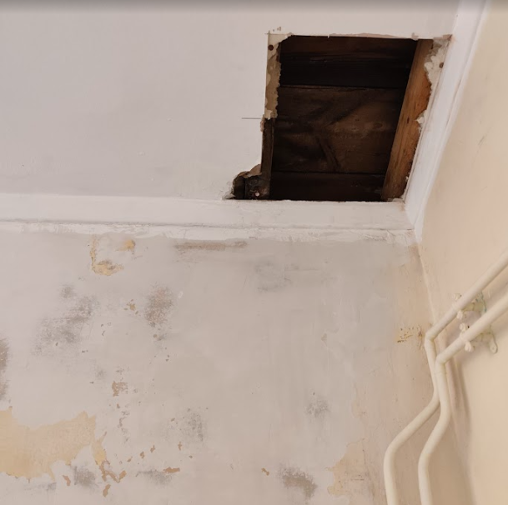
Cllr. Lethaby has inspected the roof and has suggested that the tiles be treated with a sealer. We will erecting a small amount of scaffolding to provide safe access to the roof before removing the moss and applying the sealant.
While he was inspecting the roof he was able to get this photo of the window in the roof.
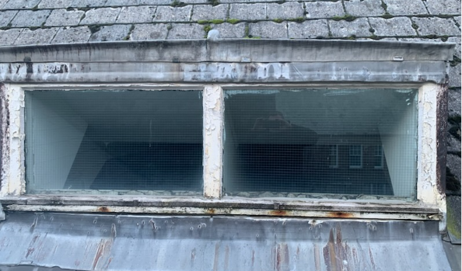
At first glance it looks like it is in reasonable condition apart from the flaking paint. It would be advisable for the Council to invest in the erection of some scaffolding to allow Andy to paint it either this year or next, before the wood starts to suffer and require a bigger, more expensive repair.
On a related note, work is about to start on the roofing repairs to Seacott. This work is being done by C&S Roofing and should finally address the damp issues that the Seacott Flat has had to endure. (The work has been delayed by having to get Western Power reroute the electric supply, so it no longer comes into the property where the roof work is to be done.)
The Clerk attended a meeting of all the beaches who have an “Access for All” beach wheelchair. Feedback from the sites was extremely positive with all the chairs (including ours) getting used regularly. Access for All are expanding the range of equipment that they loan out, to include beach friendly “rollators” which will be good for the elderly and people with conditions where they don’t wish to be in a wheelchair. Combe Martin will be having one of these to increase our “free to use” accessibility equipment list. In addition, there will be an increase in the advertising of the beaches with this equipment, which Combe Martin will benefit from.
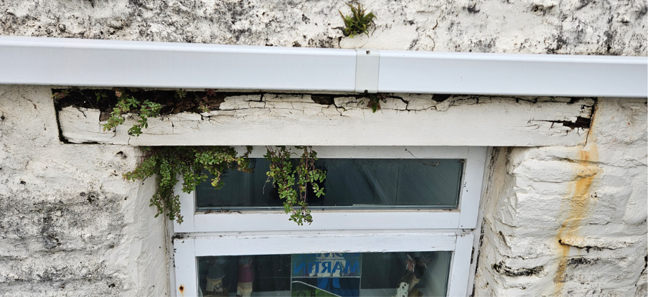
This lintel at the back of the museum is looking like it will need to be replaced soon. It is probable that it can be cut out and replaced with minimum impact on the rest of the wall but that will depend on a survey of the inside of the property.
Over December the Clerk qualified to work as a CCTV operator (Public Spaces). This will allow the Council (if it chooses to!) to fit and use cameras within the camera domes already fitted on the Kiln Car Park toilets. Having cameras would allow the Council to identify people vandalising the toilets and to provide this evidence to the police.

Appendix B

County Councillors report
January 2026
Library Consultation- reminder
A public consultation asking people to help shape the future of Devon’s 50 libraries was recently launched, this is to seek views about the future of the library service in Devon.
It will run for 12 weeks and focus on a number of options, including opening hours, the use of technology, and the potential for community-managed libraries. Closing date 22nd February.
The consultation is available online via a Devon County Council engagement platform at https://devon.cc/devon-libraries-pm
Visitors will be able to:

- Fill in one of two surveys (one is specifically for young people aged 13 to17 years)
- View a detailed overview proposal
- View an opening hours document and other information

Printed copies of the survey are also available in libraries and Devon County Council reception areas (County Hall in Exeter, Taw View in Barnstaple)

Road from St Brannocks Road to Mullacott Cross Roundabout, Ilfracombe
(not in my patch so for information only)
Devon Highways are presently carrying out drainage works to undertake repairs to the gully system in order to prevent water flowing across the carriageway on the Road from St Brannocks Road to Mullacott Cross Roundabout.
These works will be undertaken between Monday 5th – Friday 23rd January 2026.
To minimise local disruption, the majority of the works will now be done under 2-way lights, with the works across the carriageway undertaken at the end of the scheme.
There are two phases: • Monday 5th – Tuesday 20th January 2026 – 2-way lights • Wednesday 21st – Friday 23rd January 2026 – road closure
DCC will maintain access for residents within the closure but delays should be expected.
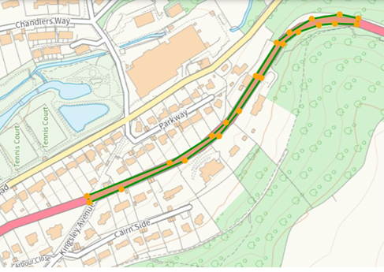
Access for emergency vehicles will always be maintained.
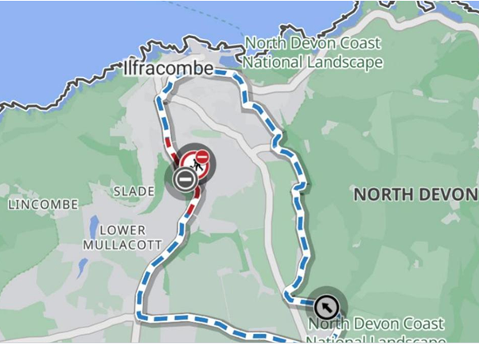

Highway Defects
With the winter now very much upon us, it is more likely there will be defects in the highway network, this includes streetlights and signs.
Report a problem - Roads and transport
Weather conditions are being constantly monitored and gritting teams are ready to be called into action when needed. However, preparations started months ago. Gritting depots across the county are topped up with almost 24,000 tonnes of salt for the start of the season.
Gritting lorries have been serviced and maintained, and five of the 37 frontline gritters have been replaced with newer models to help improve reliability and reduce maintenance costs. All of these newer gritters feature touchscreen controls to enable drivers to adjust salt spreading rates and the position of their plough attachments without leaving their cab, which improves safety.

The DCC website is very useful for reporting problems and the reports go straight to the contractor. Alternatively the highway contact number is 0345 155 1004
If it’s a river flooding the environment agency can be contacted on 0345 988 1188
Please do get in touch if you think I can help with anything; Andrea.davis@devon.gov.uk
Happy New Year, I look forward to working with you in 2026.

Andrea
County Councillor
Combe Martin Rural Division
Andrea.davis@devon.gov.uk

Appendix C

Councillors’ Monthly Briefing Paper – January 2026

This is a monthly briefing paper for Councillors to support you with the key messages to share with your Parish/Town Councils and parishioners. This has been produced at the request of the Member Development Working Group. Please provide any feedback to the Member Development Working Group.
_________________________________________________________________________

Urgent / Important Information:
Local Government Reorganisation – Potential assets for transfer to Parish/Town Councils
As you are all no doubt aware, Local Government Reorganisation (LGR) is taking place in Devon which will see the current two tier system of district and county councils abolished and replaced by unitary authorities.
We won’t know what the geography of the new authorities will look like until the summer of 2026 but a number of parish and town councils have come forward and have asked whether particular assets could be transferred to parish and town councils in advance of the new authorities being created.
Whether assets held by the District Council do transfer or not will be a decision for members and in taking that decision they will need to balance a range of considerations, including the need to ensure that the new authority is financially viable and sustainable. Having said that, if your parish or town council is of the view that your local communities would be better served by an asset being transferred to it, then now is the time to come forward and submit a request.
In making a request, I would ask you to bear in mind the following guidelines:-
- Income generating assets such as car parks are generally not likely to be transferred unless there are very strong reasons for doing so,
- Community assets such as open space, parks, public conveniences might potentially be available to transfer,
- Assets intended to cross subsidise revenue costs to maintain other community assets will not be transferred,
- Parish and Town Councils must pay the costs of the transfer,
- Any request for a transfer must be accompanied by a reasoned justification outlining the reasons why a transfer is desired at this stage, how the community will benefit from a transfer and setting out the implications on the community of the potential transfer eg: any necessary increase in the precept levied,
- Any requests for a transfer must be submitted by Thursday 12 February 2026.
It should also be pointed out that at some stage in the LGR process, a s24 direction will be issued. The effect of this will be to require the District Council to obtain the consent of the Secretary of State to any land transfer of a value of £100k or more. That direction is likely to be issued in around September 2026 and so, although individual community assets are not likely to exceed that value, any transfer should aim to be completed by that date.
It must be emphasised that the by inviting expressions of interest, the Council is not committing to undertake particular transfers. This is simply about gauging interest and the Council can then consider the implications flowing from those requests, including the impact on the resources of the Council in undertaking any transfers.
Any request should be submitted to Jon Triggs at jon.triggs@northdevon.gov.uk by Thursday 12 February.
The Community Councillor Fund closes to applications on 31st January 2026… that’s just over three weeks away!
You will need to ensure that your £1000 is totally allocated – so if you have funds left please give Kate a call so she can help you ‘spend’ it!. ….
If you were expecting to see applications come in – but they aren’t in just yet – please give those organisations a prod as they need to get them submitted
Call Kate on 01271 388253, or email grants@northdevon.gov.uk – these details can be given out to external groups.

Decisions of note:
Decisions were made regarding the following at the recent Strategy & Resources Committee (5th January 2026):
Item 7: Trade Waste Service Review
Decision taken to cease the service
Item 8: Stomas Friendly Toilets
Decision taken to approve the adaptations to 11x accessible public toilets.
The recording of the meeting is available at: Agenda for Strategy and Resources Committee on Monday, 5th January, 2026, 10.00 am | North Devon Council
The minutes will be available in due course.

Section 106 Allocations: None

Consultations:
Residents have second chance to have their say on town and parish proposals
North Devon Council is continuing its Community Governance Review in which it reviews the boundaries and electoral arrangements for towns and parishes to ensure they are effective, fair and reflect the needs of their communities.
A number of town and parish councils put forward initial proposals, which were consulted on between July and September. Having considered the feedback received, a further consultation is now taking place until the end of January 2026.
Residents in the affected parishes are encouraged to take part in the consultation, which is open until 30 January 2026.
Residents can view the detailed proposals and take part in the consultation by visiting northdevon.gov.uk/lets-talk and completing the survey that affects them.

