Minutes of the Combe Martin Parish Council Meeting,
held on 14th September 2026 at 7pm at Combe Martin Community Centre.

Present: Cllrs. Seldon (Chairman), Lethaby, Molloy, Optix, Smallridge, and Worth.
Also in attendance: Andrew Wyer (Clerk) and 5 members of the public.
054/26 Apologies – Apologies were received and accepted from Cllr. Richards. Cass, Corner, Masters, and Watkins.
055/26 Declarations of Interest – Cllr Lethaby declared that as a District Councillor, the views he gives (and how he votes) at this meeting will not necessarily be the same as he does at a District Council meeting.
056/26 Public Participation questions (with any answers in brackets):
Newberry Shelter – Repairs needed. (This has been referred to the supplier previously and will be chased up again.
Planting Displays – some displays need work doing to them. (Most of our tubs and features are tended to by volunteers with the Parish Council refunding the cost of plants.)
Temporary Housing – the member of the public had been to NDC on 22nd July and none of the next wave of houses to be bought would be in villages.
057/26 Co-option – The Council heard from 3 candidates wishing to become a CMPC Councillor.
058/26 Minutes – The Minutes for the Council meeting held on Monday 13th July 2026 were approved and signed.
059/26 Clerks Report – The report had been distributed prior to the meeting and the Clerk gave a verbal update, confirming that the bus stop on King Street was definitely a CMPC asset. The report was then noted. The Council resolved to make the recommended transfers and payments from Earmarked Reserves.
060/26 County Cllr & District Cllr reports – Cllr. Davis (DCC) had sent her report, and it had been distributed to Councillors ahead of the meeting. It is attached as Appendix 1.
Cllr Lethaby reported that NDC was in the process of purchasing a woodland (with Grant money).
061/26 NDC planning: None
062/26 Exmoor NPA: None
063/26 Planning Decisions: None
064/26 Planning Correspondence: Letter and drawings for a proposed communications installation was noted.
065/26 Finance – The Council reviewed the list of invoices to be paid and then they approved these payments, totalling £22,733.36
066/26 Finance – The Council noted the “Receipts”, “Payments”, and “Dashboard” for July/August.
067/26 Finance – The Council noted the External Auditor’s Report & Certificate and further approved the “Notice of Conclusion of Audit”.

068/26 Pension Scheme – The Council confirmed that all council staff were eligible to join the pension scheme.
069/26 Kiln Car Park Toilets – The Council resolved to take over the toilets from North Devon Council pending the completion of any maintenance matters and to agreeing a suitable legal transfer. The Council reviewed the proposed Heads of Terms and instructed the Clerk to request the removal of the use restrictions.
070/26 Kiln Car Park Toilets – The Council resolved to defer this issue to the next Council meeting, allowing Councillors time to decide what service they needed to outsource.
071/26 Wood Lane CCTV – The Council resolved to install 2 cameras at the Wood Lane site.
072/26 Land Registry – The Clerk reported that 15 properties were currently in the process of being registered. A further 2 properties are more complicated and will be more expensive. The Council resolved to push on and get these properties registered, to complete another job that previous Councils had ignored.
073/26 Emergency Plan – The Council resolved to continue developing the current draft.
074/26 Vehicles on the beach – The Council resolved to implement a firm ban on vehicles between 10 am and 6 pm.
075/26 Beach Risk Assessment – The Council adopted the Beach Risk Assessment with the amended 10-6 vehicle ban.
076/26 Bollards in Kiln Car Park – The Council resolved to price up installing bollards to protect the footpath. This will be brought to the Budget Council meeting in November.
077/26 Fireworks – The Council resolved to match the £1000 grant from the Community Shop for this community event.
078/26 Council Vehicle – The Council resolved to take advantage of the parking income windfall to replace the council pick-up. The Council identified a brand new 4WD Suzuki Carry pick up as matching the workmen’s needs and the being at the correct budget of approx. £15,000. The Clerk was instructed to buy this vehicle and to sell the current vehicle while it still had an MOT and therefore some value.
079/26 Campaign to Protect Rural England – The Council approved joining CPRE.
080/26 Correspondence – The Council noted the correspondence.
081/26 Date of next meeting –
Monday 12th October 2026 - Council meeting 7pm at Community Centre
Monday 26th October 2026 – Parking Charges meeting BUT ONLY IF parking charges cannot be resolved at the 12th of October meeting.
082/26 Exclusion of Press & Public - The Council resolved to exclude the press and public for the following item due to the likelihood of disclosure of confidential information.
083/26 Co-option – The Council reviewed the candidates and elected Bruce South to join the Council.

The meeting closed at 9.15pm.

Appendix 1
Combe Martin Parish Council
County Councillors Report
September 2026
Local Government reorganisation
The Government announced on 7 September 2026 that it is pausing and reviewing the planned local government reorganisation in Devon. Housing Secretary Angela Rayner told Parliament that the decision followed legal advice and that the Government wants to ensure the process is robust, lawful and aligned with the priorities of the new Prime Minister.
The paused plan would have replaced Devon’s current two-tier system with four unitary authorities, abolishing Devon County Council and the district councils.
A key consequence of the decision is that local elections are expected to proceed on existing council boundaries in May 2027, rather than under any new unitary structures. So that means the District council elections will take place next May.
1. No immediate change to council services
Residents will continue to receive services through the existing arrangements involving:
- Devon County Council
- North Devon Council
- Combe Martin Parish Council
There are no immediate changes to waste collection, highways, planning, social care or education services.
2. North Devon Council remains in place
Under the previously approved reorganisation, North Devon Council would eventually have been abolished and merged into a much larger authority covering a large rural area of Devon. The pause means North Devon Council continues as normal for now.
3. Continued local representation
Many concerns in rural North Devon centred on whether a large county-wide rural authority would weaken the voice of smaller settlements such as Combe Martin. The postponement means existing district and parish representation remains unchanged while the review takes place.
4. Uncertainty remains
The Government has not cancelled reorganisation entirely. It has paused and reviewed the programme, meaning Devon could still face structural changes later. The final shape of local government in North Devon therefore remains uncertain.
5. Financial implications
Devon councils have already committed significant officer time and resources to preparing for LGR. As the former deputy leader of Devon County Council I would estimate that millions of pounds have been spent across the county, and those costs will not be recovered regardless of the eventual outcome.
Key message for Combe Martin Rural
The most important takeaway is that nothing changes immediately for residents or local services. North Devon's existing councils remain in place, local elections are expected to go ahead as normal in 2027, and the future structure of local government in Devon is now subject to a fresh Government review.

Closed road A3123 Berrydown (a key route for most of my area)
Monday 28th sept- Wednesday 30TH September
7am-6pm
Drainage investigation works.

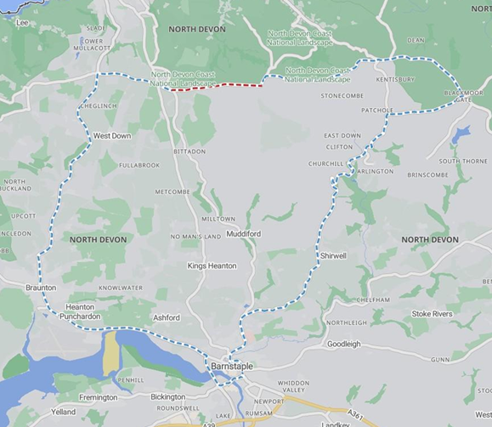
Other items for Combe Martin

I have asked for various places to receive patching in the Parish, I have not yet heard the result of that request.
I’ve also asked for the bus stop at Seaside to be looked at as I have observed some issues around traffic flow, passengers getting on and off etc.
Some potholes have been reported which I’m hoping will soon be sorted out.
Please report online any issues you notice.
Report a problem - Roads and transport

I’m hoping to very soon to be doing some speed recordings in the village, I’ve had a number of complaints recently, please report traffic issues here; Report a road traffic incident | Devon & Cornwall Police

Andrea Davis
County Councillor
Andrea.davis@devon.gov.uk

